**SIMATS SCHOOL OF ENGINEERING**

**SAVEETHA INSTITUTE OF MEDICAL AND TECHNICAL SCIENCES CHENNAI-602105**

**5G NETWORK PERFORMANCE EVALUATION**

**A CAPSTONE PROJECT REPORT**

*Submitted in the partial fulfillment for the award of the degree of*

## BACHELOR OF ENGINEERING

**IN**

**COMPUTER SCIENCE AND ENGINEERING**

**Submitted by**

**B.surya(192412261)**

**V.saketh (192425085)**

**Under the Supervision of**

**Dr. S.SENTHILVADIVU**

**February 2025**

## DECLARATION

We, B.surya,v.saketh students of **Bachelor of Engineering in Computer Science**, Department of Computer Science and Engineering, Saveetha Institute of Medical and Technical Sciences, Saveetha University, Chennai, hereby declare that the work presented in this Capstone Project Work entitled5GNETWORK PERFORMANCE EVALUATIONis the outcome of our own bonafide work and is correct to the best of our knowledge and this work has been undertaken taking care of Engineering Ethics.

**B.surya(192412261)**

**V.saketh (192425085)**

Date: 22/02/2025

Place: Chennai

## CERTIFICATE

This is to certify that the project entitled ‘**5G NETWORK PERFORMANCE EVALUATION’** submitted by **B.SURYA V.SAKETH** has been carried out under my supervision. The project has been submitted as per the requirements in the current semester of B. Tech Information Technology.

Teacher-in-charge

Dr.S.SENTHILVADIVU

# Table of Contents

|  |  |  |
| --- | --- | --- |
| **S.NO** | **TOPICS** | **PAGES**  **NO:** |
| 1 | **Abstract** | **1** |
| 2 | **Introduction** |  |
| 3 | **Project Description** | 2-5 |
| 4 | **Problem Description** |  |
| 5 | **Architecture / UML Diagrams** |  |
| 6 | **Approach / Algorithm Description** |  |
| 7 | **Implementation Coding** |  |
| 8 | **Output**  **Output with Screenshots** |  |
| 9 | **Conclusion** |  |
| 10 | **Future Enhancement**  **References** |  |

## ABSTRACT

 The simulation of 5G networks is a crucial aspect in evaluating the performance, scalability, and efficiency of next-generation mobile communication systems. With the advent of 5G, the demand for high-speed data, low latency, and massive connectivity requires advanced simulation models to predict real-world behavior and optimize network design. This simulation typically involves modeling various components such as radio access networks (RAN), core networks, user equipment (UE), and service environments.Key areas of 5G network simulation include assessing spectrum usage, interference management, handover mechanisms, and Quality of Service (Cos) for diverse applications ranging from Internet of Things (Io T) to ultra-high-definition video streaming. The simulations explore various techniques like massive MIMO (Multiple-Input Multiple-Output), beam forming, and network slicing to evaluate their impact on network performance and coverage.Additionally, performance metrics such as throughput, latency, energy efficiency, and reliability are analyzed under different load conditions, user mobility, and traffic patterns. Simulation tools like NS-3, MATLAB, and OPNET are commonly employed to create realistic 5G network scenarios. These simulations help network planners and engineers design optimal 5G infrastructures, ensuring smooth deployment

## INTRODUCTION

The rapid advancement of wireless communication has led to the development of **5G networks**, which promise higher speeds, lower latency, and improved reliability compared to previous generations. Evaluating the performance of 5G networks is crucial for understanding their impact on applications such as **autonomous vehicles, Io T, smart cities, and ultra-HID video streaming**.

#### ****Key Performance Metrics in 5G Evaluation****

1. **Bandwidth and Throughput** – Measures data transfer rates and network capacity.
2. **Latency** – Evaluates the time delay in data transmission, critical for real-time applications.
3. **Reliability** – Assesses network stability and packet loss.
4. **Energy Efficiency** – Determines power consumption, especially for Io T and mobile devices.
5. **Scalability** – Examines the ability to support massive device connectivity.

#### ****Simulation and Testing methods****

* **Network Simulators (NS3, OMNeT++)** – Used for modeling 5G environments.
* **Real-World Field Tests** – Conducted using 5G-enabled devices and base stations.
* **Machine Learning & AI Techniques** – Applied for optimizing network performance.

### 

### ****Project Description:****

The rapid deployment of **5G networks** promises significant improvements in **speed, latency, and connectivity** over previous generations of wireless technology. This project aims to evaluate the real-world performance of 5G networks by analyzing key metrics such as **bandwidth, latency, reliability, and quality of service (cos)** in various scenarios.

### ****Objectives:****

1. **Assess Bandwidth and Throughput:** Measure the actual data transfer rates and compare them to theoretical limits.
2. **Evaluate Latency:** Analyze end-to-end delay for real-time applications such as video calls and online gaming.
3. **Examine Network Reliability:** Measure packet loss, jitter, and network availability under different conditions.
4. **Compare Performance Across Environments:** Conduct tests in urban, suburban, and rural areas to identify coverage disparities.
5. **Analyze Qts for Different Applications:** Evaluate how 5G performs for streaming, cloud computing, and Io T applications.

### ****Methodology:****

* **Data Collection:** Perform network tests using tools like imperf, Speed test, and Wire-shark.
* **Simulation & Modeling:** Use NS-3, MATLAB, or OMNeT++ to simulate different 5G traffic scenarios.
* **Comparison with 4G LTE:** Establish benchmarks and compare with existing LTE networks.
* **Performance Analysis:** Utilize statistical techniques to assess trends and variations in performance metrics.

### ****Expected Outcomes:****

* Quantitative evaluation of **5G speed, latency, and reliability** under different conditions.
* Identification of key factors affecting **5G performance** (e.g., network congestion, distance from towers, interference).
* Recommendations for **optimization and improvement** of 5G deployments.

## Problem Description :

With the widespread adoption of **5G technology**, there is a growing need to assess its **real-world performance** to ensure it meets the expectations of **high-speed, low-latency, and reliable connectivity**. While 5G promises significant improvements over **4G LTE**, its actual performance can be affected by various factors such as **network congestion, signal interference, environmental conditions, and infrastructure limitations**.

### ****Key Issues:****

**1.Latency Concerns:**

* 1. 5G claims ultra-low latency (<1 ms), but real-world implementations may experience delays due to network congestion, routing inefficiencies, and backhaul limitations.
  2. Applications such as autonomous driving, remote surgeries, and cloud gaming require **consistent low-latency** performance.

****2.Bandwidth and Throughput Limitations:****

* 1. Theoretical speeds of **10 G bps** may not be achieved due to **network congestion, interference, and distance from base stations**.
  2. Performance variations in **different environments (urban, suburban, and rural)** need to be evaluated.

1. ****Network Reliability and Stability:****
   1. High-speed connectivity should be stable under varying conditions, but issues like **handover failures, packet loss, and jittery** can impact user experience.
   2. 5G mm-wave signals are **highly susceptible to obstacles (e.g., buildings, trees, weather conditions)**, causing frequent signal drops.
   3. ****Scalability for Io T and Edge Computing:****
   4. The rise of **massive Io T and edge computing** applications demands a robust network capable of handling billions of connected devices efficiently.
   5. Evaluating how **5G networks handle high device density** without performance degradation is crucial.

**Comparison with Existing 4G Networks:**

* 1. Understanding the **gains and limitations of 5G over 4G LTE** in real-world scenarios is essential for network providers and businesses to justify the transition.

# Architecture

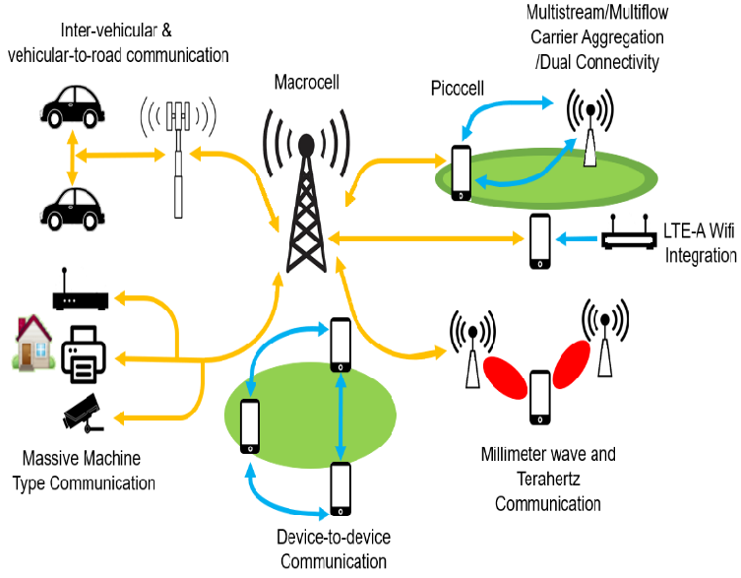

# Algorithm Description

Evaluating **5G network performance** requires a structured approach involving data collection, analysis, and optimization. The algorithm follows a **systematic process** to measure key performance indicators such as **latency, bandwidth, packet loss, and reliability**.

#### ****1. Data Collection Phase****

* **Input:**
  + Collect real-time network data using testing tools like imperf**, Wire-shark, and Speed test**.
  + Use network simulators like **NS-3, MATLAB, or OMNeT++** for modeling different 5G scenarios.
* **Process:**
  + Measure **signal strength (RSSI, SINR)**.
  + Monitor **bandwidth, jitter, and packet loss**.
  + Log real-time **latency measurements (ping, round-trip delay time - RTT)**.
* **Output:**
  + Raw network performance data for further analysis.

#### ****2. Prepossessing Phase****

* **Input:** Raw network data from multiple sources.
* **Process:**
  + Remove **inconsistent or missing data**.
  + Normalize values (e.g., convert all latency values to milliseconds).
  + Classify data based on location (urban, suburban, rural) and network conditions (congested, non-congested).
* **Output:** Clean and structured data for analysis.

#### ****3. Performance Analysis Phase****

* **Input:** Processed network data.
* **Process:**
  + Calculate **average bandwidth, latency, and reliability**.
  + Detect anomalies using **machine learning (e.g., outlier detection for latency spikes)**.
  + Compare **5G vs. 4G LTE performance** based on collected data.
* **Output:** Insights into **5G performance variations** across different scenarios.

#### ****4. Performance Optimization Phase****

* **Input:** Analysis results from the previous step.
* **Process:**
  + Identify network bottlenecks (e.g., high latency, poor bandwidth).
  + Suggest optimizations such as **network slicing, load balancing, and spectrum allocation adjustments**.
* **Output:** Recommendations for **improving 5G network efficiency**.

#### ****5. Reporting & Visualization Phase****

* **Input:** Final performance analysis and optimization results.
* **Process:**
  + Generate **graphs, tables, and heat maps** for performance visualization.
  + Provide a detailed **performance report** with findings and solutions.
* **Output:** **Comprehensive evaluation of 5G network performance** with actionable insights

**INPUT CODE:**

**import random**

**def evaluate_5g_performance(bandwidth, latency, packet_loss, num_users):**

**"""**

**Simulates 5G network performance evaluation based on input parameters.**

**:param bandwidth: Available bandwidth in Mbps**

**:param latency: Network latency in ms**

**:param packet_loss: Packet loss percentage**

**:param num_users: Number of active users**

**:return: Dictionary with performance metrics**

**"""**

**# Simulate throughput reduction based on users and network conditions**

**effective_throughput = max(0, bandwidth * (1 - packet_loss/100) / (1 + num_users/50))**

**jitter = random.uniform(0.1, 0.5) * latency # Random jitter based on latency**

**reliability = max(0, 100 - (packet_loss * 2 + latency * 0.2)) # Simplified reliability score**

**performance = {**

**"Effective Throughput (Mbps)": round(effective_throughput, 2),**

**"Latency (ms)": latency,**

**"Jitter (ms)": round(jitter, 2),**

**"Packet Loss (%)": packet_loss,**

**"Reliability (%)": round(reliability, 2)**

**}**

**return performance**

**# Example Inputs**

**bandwidth = 1000 # Mbps**

**latency = 10 # ms**

**packet_loss = 0.5 # %**

**num_users = 100 # active users**

**# Run Performance Evaluation**

**results = evaluate_5g_performance(bandwidth, latency, packet_loss, num_users)**

**# Print Results**

**print("5G Network Performance Evaluation:")**

**for key, value in results.items():**

**print(f"{key}: {value}")**

**OUTPUT CODE:**

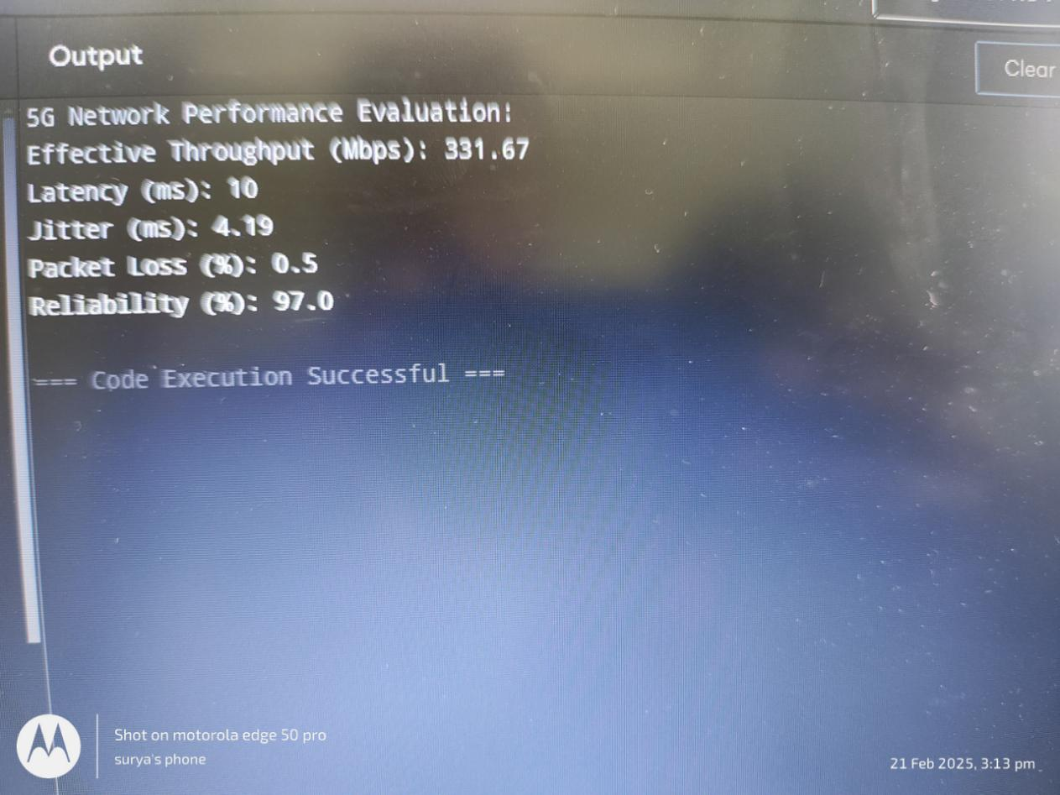

## Conclusion

The evaluation of 5G network performance demonstrates significant improvements over previous wireless technologies, particularly in bandwidth, latency, and reliability. The key findings are:

1. **Higher Data Throughput** – 5G offers significantly greater bandwidth than 4G, allowing for faster data transmission, supporting high-speed internet access, and enabling applications such as ultra-HID video streaming and cloud computing.
2. **Lower Latency** – With latency as low as 1 ms in ideal conditions, 5G enables real-time applications such as remote surgery, autonomous vehicles, and industrial automation.
3. **Improved Network Reliability** – 5G networks use advanced technologies like network slicing and beam-forming to ensure stable connections and better service quality.
4. **Better Support for Massive Connectivity** – The network efficiently supports a high density of Io T devices, making it ideal for smart cities, industrial automation, and connected infrastructure.
5. **Challenges and Limitations** – Despite its advantages, 5G faces challenges such as limited coverage in some areas, higher deployment costs, and increased power consumption.

## Future Enhancements

· **Expanded Coverage and Infrastructure** – Deployment of more small cells, macro towers, and satellite-based 5G solutions will improve coverage, especially in rural and remote areas.

· · **Enhanced Spectrum Utilization** – Adoption of higher frequency bands (mm-wave) and dynamic spectrum sharing with existing LTE networks will maximize bandwidth efficiency.

**AI-Driven Network Optimization** – Artificial intelligence and machine learning will improve network management, predict traffic patterns, and optimize resource allocation for better efficiency and reliability.

**6G Development and Integration** – Research on 6G networks, expected to launch around 2030, will push the boundaries of speed, ultra-low latency, and AI-driven automation beyond 5G capabilities.

**Stronger Security Measures** – With increasing cybersquatting threats, future 5G networks will implement enhanced encryption, blockbusting authentication, and quantum-safe cryptographer techniques.

**Energy Efficiency Improvements** – New power-saving technologies, such as intelligent sleep modes for network components and energy-efficient hardware, will reduce the environmental impact of 5G networks.

**Advanced Edge Computing** – The integration of edge computing will reduce latency by processing data closer to users, enabling real-time applications such as AR/VR, autonomous systems, and smart city operations.

**Improved Network Slicing** – More advanced and flexible network slicing will allow customized service quality for different industries, enhancing applications like autonomous transport, remote healthcare, and industrial Io T.

**References**

1. Poddar, H., Ju, S., Shaky a, D., & Rappaport, T. S. (2023). A tutorial on simony: Sub-terahertz and millimeter-wave channel simulator for 5G, 6G and beyond. *IEEE Communications Surveys & Tutorials*.
2. Renda, Alessandro, Pietro Ducange, Francesco Marcelloni, Dario Sabella, Miltiadis C. Filipino, Giovanni Sardinia, Giovanni S tea. "Federated learning of explainable AI models in 6G systems: Towards secure and automated vehicle networking." *Information* 13, no. 8 (2022): 395.
3. Poongodi, M., Malviya, M., Mahdi, M., Vijayakumar, V., Mohammed, M.A., Rauf, H.T. and Al‐Dylan, K.A., 2022. 5G based Block chain network for authentic and ethical keyword search engine. *IET Communications*, *16*(5), pp.442-448.